IRINA NUZOVA

PIANIST

Critics have applauded classical pianist Irina Nuzova for her “rise above mere virtuosity” (The Washington Post), “intensity of feeling” (La Nazione, Italy) and “profound interpretation” (Il Resto de Carlino, Bologna).

Nuzova has appeared in recital as a soloist and as a chamber musician in the United States, Europe, and South America. In Europe, she has performed as part of the Amici della Musica concert series in Florence; at the Teatro Massima in Catania, Italy; Hermitage State Museum in St. Petersburg; the Moscow Conservatory, and in the Netherlands. In the United States, she has played at the Phillips Collection in Washington D.C., Carnegie Hall’s Weill Recital Hall and the Kosciuszko Foundation in New York; and as part of chamber music series including the Rhode Island Chamber Music Concert Series and the Dame Myra Hess Memorial Concert Series in Chicago. In recital with Wendy Warner, Nuzova has performed at the Music Institute of Chicago, the Phillips Collection in Washington D.C., and as part of the Rockefeller tri-Institutional series in New York City.
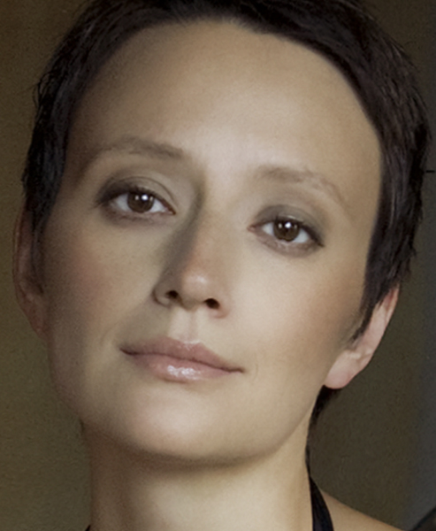
Nuzova kicked off the 2010-2011 season with the WarnerNuzova duo’s debut release: Russian Music for Cello & Piano on Cedille Records. The CD entered the Billboard charts as #8, and has been featured on more than 100 radio stations. Warner and Nuzova have played together for years, but officially formed the duo in 2008 with the intention of performing and recording the canonical sonatas for cello and piano from the past and present, as well as commissioning unique arrangements and new music. This first album covers romantic Russian works featuring among others the rarely performed Sonata in A Minor by Nikolai Miaskovsky. Nuzova regards the Miaskovsky sonata a “rare gem,” adding that she likes to flip the Russian maxim which reads: “All is not gold that glitters,” to say “Something that does not glitter can still be gold” in regards to the composer and this sonata in particular. Says Nuzova, “The sonata’s pervasive, nostalgic quality speaks to the Russian soul and mind, but it is subtle and subdued in its expression, and absolutely jewel-like in its clarity and simplicity.”
This season Nuzova appears as soloist in numerous venues; and will also be featured with her duo at St. Paul’s Music in the Park Series; in Chicago's Music Institute, and at the Phillips Collection in Washington, D.C., presenting the complete Beethoven sonatas cycle. Ms. Nuzova also appeared in live radio interviews and performances in Boston, Chicago, Philadelphia, Washington DC, among others. WarnerNuzova played the five Beethoven cello/piano sonatas for a live broadcast on WFMT in Chicago; and was invited by Fred Child of Performance Today -- a program that was syndicated nationwide.
The recipient of the Bruce Hungerford Award at the Young Concert Artist Auditions in New York, Nuzova has won top prizes in competitions such as the Vincenzo Bellini and Citta di Senigallia International Competitions in Italy and the Beethoven Piano Sonata International Competition in Memphis, Tennessee. As a chamber musician, she has won top prizes at the Vittorio Gui and the Premio Trio di Trieste International Chamber Music Competitions in Italy. Nuzova’s performances have been broadcast live on WFMT in Chicago, WGBH in Boston, and Italian TV.
Nuzova is a native of Moscow, Russia. Her mother was a professional piano instructor who took her daughter for her first piano lesson at age five. Nuzova made her debut with the Omsk Philharmonic at the age of 14. She studied at the Gnessin Academy of Music under the guidance of Alexander Satz before moving to the United States. She continued her musical education at the Manhattan School of Music with Lev Natochenny, and at Juilliard where her teachers were Oxana Yablonskaya and Jerome Lowenthal. To further herself as a musician she worked for many years in the cello studio of Harvey Shapiro at Juilliard and pursued individual studies with pianists Jean-Bernard Pommier, Eteri Andjaparidze, and Vladimir Feltsman. Nuzova earned her Doctorate of Musical Arts degree from the Hartt School of Music (University of Hartford, Connecticut).

www.irinanuzova.com

